

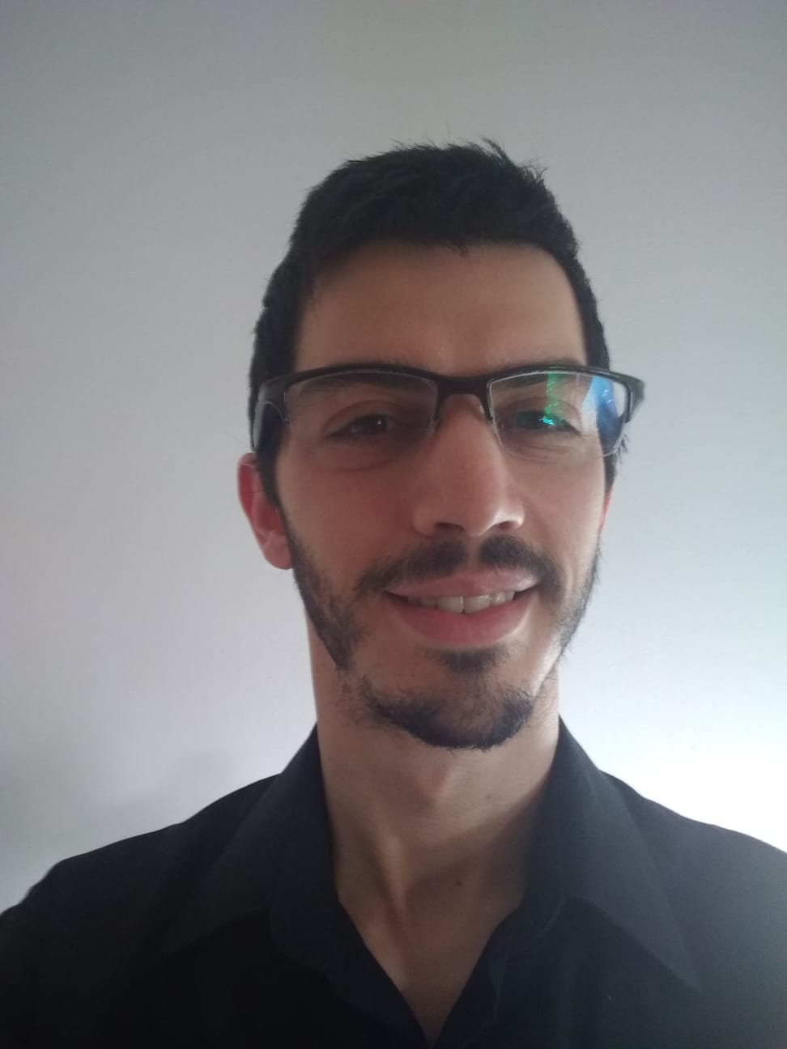

frandepaulo@yahoo.com.ar

+54 2392 561047

https://frandepaulo.netlify.app



FRANCO DE PAULO



Front End Developer

La Plata

Buenos Aires, Argentina



98

**EXPERIENCE**

**PRESENTATION**

After working in the music industry for over 10 years, I decided to turn my career around and dive right into the digital world and programming.

I am passionate about design and the Frontend, it motivates me to be in permanent evolution and apply new technologies.

I am currently doing the back end module in the NUCBA web developer full stack bootcamp, and I am looking to have my first professional experience in the IT field.

**Institute NUCBA**

10

PRACTICES IN FRONT END

Although I am looking for my first work experience in the IT world, I did several projects as an internship covering all the technologies that I have learned.

**Jobs outside the technological field**

2019-2021 .Canine Stylist - Royal Clan Grooming

2017-2019 .Customer service and dog groomer - Brothers pet shop

2011-2020 .Professional musician

2009-2011 .Commissioner - Independent

10

10

12

**SKILLS**

**REACT.JS**

**HTML**

**CSS**

**BOOTSTRAP**



**SASS**

**FIREBASE**

**STUDIES**

11

**JAVASCRIPT**

10

**TYPESCRIPT**

**PROFESSIONAL MUSICIAN / JAN 2017 – MARCH 2020**

EMU

Music career at EMU jazz school.

131010

Portfolio: https://frandepaulo.netlify.app

**TEAM WORK**

GitHub: https://github.com/frandepe

LinkedIn: https://www.linkedin.com/in/franco-de-paulo-13509b186

**SOFT SKILLS**

**WEB DEVELOPER / JAN 2021 – ACT.**

**INGLES / JAN 2020 – FEB 2021**

**CREATIVITY**

**ADAPTATION**

**PATIENCE**

**RESOLUTION**

Full stack web development bootcamp. Finalizing the back end module.

NUCBA

Intermediate English course at Feedback institute

Feedback School Of English Language